HAIP
Healthcare Analytics & Intelligence Platform
A unified, AI-powered hospital decision-support system
Capstone Project Presentation
Proof-of-concept on synthetic data · triage aid, not diagnosis
Full-stack · Machine Learning · Retrieval-Augmented Generation · Agentic AI

1. Executive Summary
HAIP (Healthcare Analytics & Intelligence Platform) is a full-stack, multi-service proof-of-concept that unifies four distinct clinical-support capabilities behind a single hospital-facing interface. It combines machine-learning risk prediction, retrieval-augmented knowledge search, provider-performance analytics, and an agentic clinical assistant that reasons across all of them. The guiding principle throughout is honest engineering: real metrics, disclosed limitations, and every automated decision kept reviewable by a human.
The system solves a concrete problem: hospital data, clinical guidelines, and predictive models normally live in separate, disconnected tools. A clinician or administrator has to move between systems to answer a single operational question. HAIP connects backend, frontend, analytics, and reporting into one smooth end-to-end workflow — upload a dataset, validate it, explore it, predict risk, forecast admissions, and export a report, all in one place, with a conversational agent on top that can answer questions using every underlying capability.

What is demonstrable today
- Four working entry points ("cards"): Hospital Data, Doctors, Knowledge Base, and Ask HAIP — all live end-to-end.
- A six-service Docker Compose application: FastAPI auth, three analytics apps, an agent service, and a React frontend.
- PDF report generation, admission forecasting, an architecture flowchart, and an automated test suite.
- A RAG knowledge base over 6,832 chunks of WHO / CDC / NICE guidance, and a LangGraph agent that calls real tools on the uploaded data.

2. Problem Statement & Motivation
Hospitals generate large volumes of operational and clinical data, but the tools to act on it are fragmented. Risk scoring, guideline lookup, provider benchmarking, and forecasting are typically four separate products, each with its own login, data format, and learning curve. This fragmentation slows decisions and discourages routine use of analytics at the point of care.

2.1 The core problem
A clinician asking a simple operational question — "given our current admissions, what risk are we carrying, and what does the guidance say?" — has no single place to get a grounded answer. HAIP was built to close that gap: one platform, one upload, four connected capabilities, and an agent that can reason across them.

2.2 Design constraints
The project was deliberately built to run on modest, self-contained infrastructure: a single RAM-constrained development machine, no cloud dependency for core function, and synthetic data only. These constraints shaped many engineering choices described later — lightweight embeddings, lazy service loading, and CSV/SQLite/FAISS storage rather than a heavy database cluster.

2.3 Honest-engineering commitment
Every output in HAIP is framed as a triage aid on synthetic data, not a diagnostic decision. Metrics are reported truthfully (PR-AUC is preferred over ROC-AUC for imbalanced clinical targets, explained in §7), limitations are disclosed rather than hidden, and every automated route the agent takes is shown to the user for review. Nothing is inflated for presentation.

3. Data: Sourcing, Processing & Current Use

3.1 How the data was synthesised
Because real patient data cannot be used in a student project for privacy and regulatory reasons, HAIP was developed against Synthea, an open-source synthetic patient generator. Synthea produces statistically realistic but entirely fictional patient records — demographics, encounters, conditions, medications, and outcomes — with no connection to any real individual. Approximately 1,165 synthetic patients were generated for development and model training.

3.2 The medallion pipeline (built, for development)
The Synthea output was organised using a medallion architecture, a widely used data-engineering pattern that layers data by refinement level:
- Bronze — raw Synthea output, ingested as-is.
- Silver — cleaned, typed, and joined encounter/condition tables.
- Gold — feature-ready tables used to train the risk models.
This pipeline demonstrates a professional, reproducible approach to data preparation and was used to develop and validate the machine-learning components.

3.3 What the live application actually uses
This is an important and deliberately honest point. The live HAIP application does not run on PostgreSQL or the Synthea warehouse. The demonstrable system is designed to work on any hospital's own uploaded data. Its runtime storage is deliberately lightweight:
Store | Role in the live app
CSV upload | The user's hospital dataset — the primary live input for prediction and analytics.
SQLite | Lightweight application state and lookups.
FAISS | Vector index for the RAG knowledge base (6,832 guideline chunks).

In short: the Synthea pipeline is the training and development story; the live product is a bring-your-own-data tool. Framing this honestly is a strength — it shows the system generalises beyond the synthetic dataset it was built on.

4. System Architecture
HAIP is a six-service application orchestrated with Docker Compose. A React frontend presents a single UI; behind it, five backend services each own one capability. Services are loosely coupled — the three analytics apps are embedded in the UI as framed views, while the agent is called natively over HTTP.
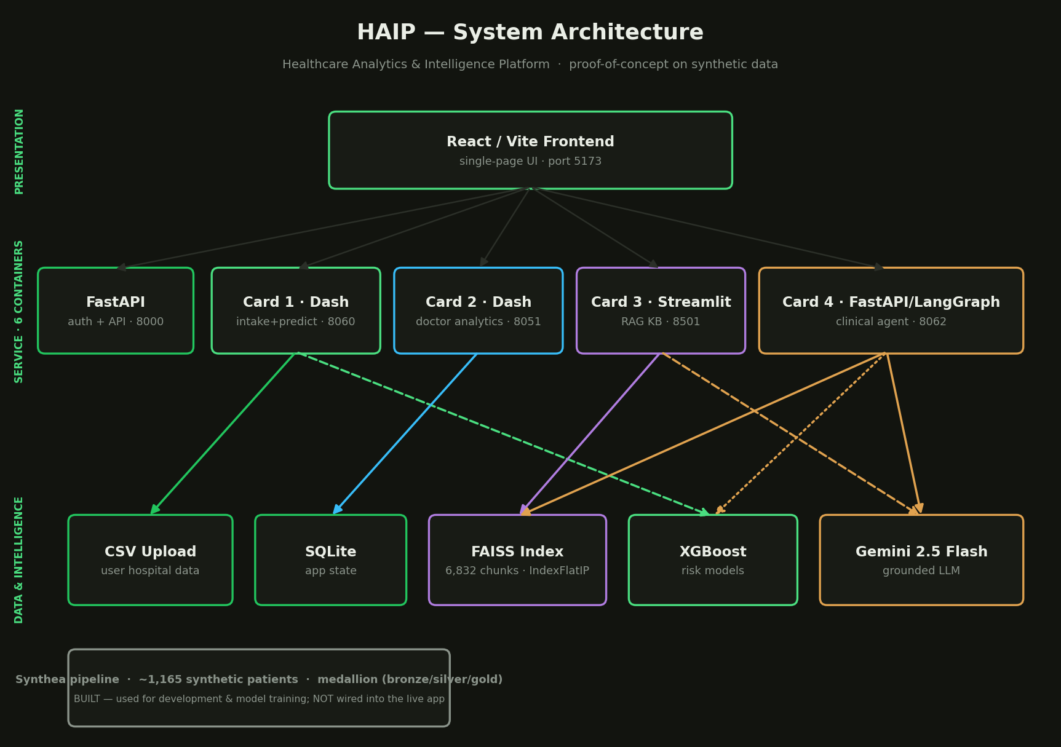
Figure 1 — HAIP system architecture across presentation, service, and data layers.

4.1 The six services
Service | Port | Technology | Responsibility
FastAPI | 8000 | FastAPI | Authentication and the API layer.
Card 1 · merged_app | 8060 | Dash / Plotly | Hospital data intake, prediction, PDF report.
Card 2 · doctor_app | 8051 | Dash / Plotly | Risk-adjusted provider analytics.
Card 3 · RAG | 8501 | Streamlit | Guideline knowledge base (RAG).
Card 4 · agent_app | 8062 | FastAPI / LangGraph | Agentic clinical assistant.
Frontend | 5173 | React / Vite | Single-page unified UI.

4.2 Why this shape
A multi-service design lets each capability use the best tool for its job — Dash for interactive analytics dashboards, Streamlit for the document-centric RAG interface, and a dedicated FastAPI/LangGraph service for the agent — while the React shell keeps the experience unified. Services load lazily so the whole stack stays within the memory budget of a single development machine.

5. The Four Cards: End-to-End Workflow
The heart of HAIP is a set of four "cards" — four entry points into the same platform. A hospital's data flows through them as a connected pipeline rather than four disconnected tools.
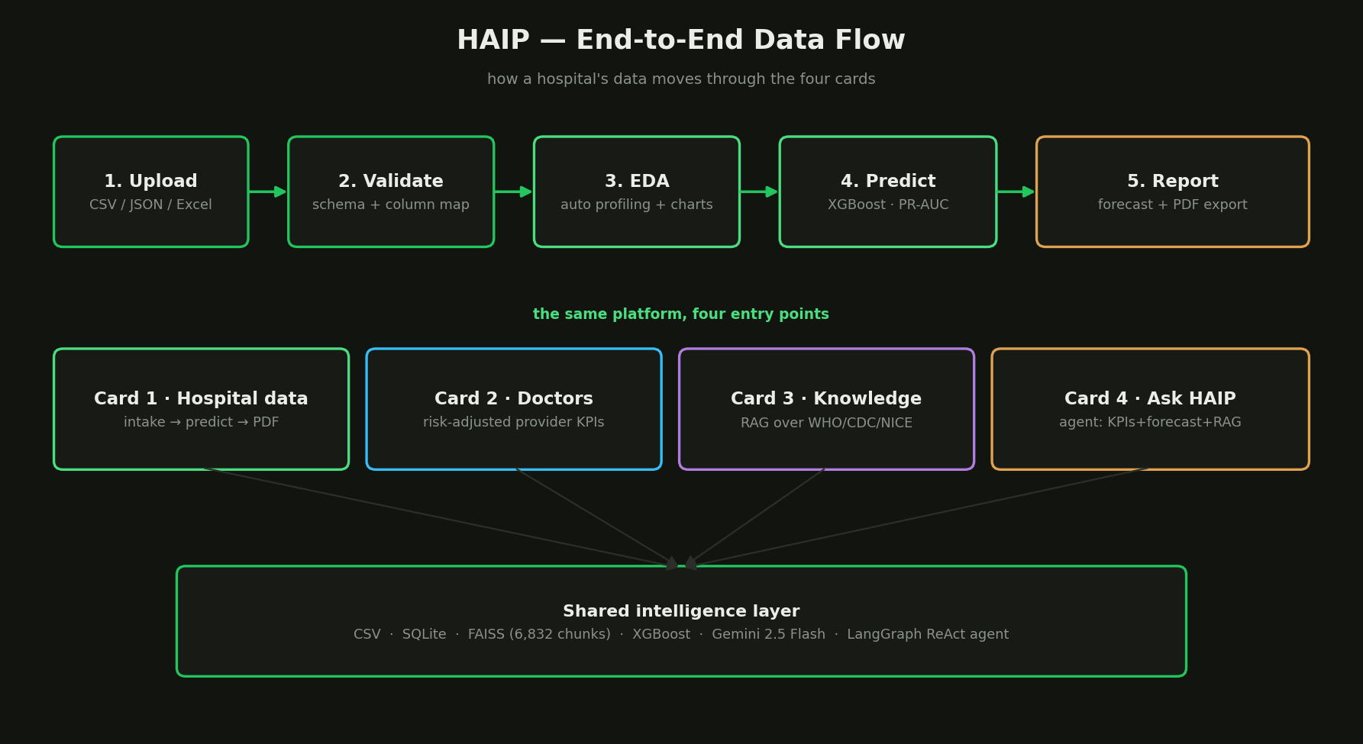
Figure 2 — End-to-end data flow: upload → validate → explore → predict → report, surfaced through four cards.

5.1 Card 1 — Hospital Data (intake → predict → report)
Card 1 is the primary workflow. A user uploads a CSV, JSON, or Excel dataset; the system validates the schema and offers automatic column mapping, runs exploratory data analysis with auto-generated charts, applies XGBoost risk prediction, forecasts future admissions, and exports a PDF report.
- Upload & validate — schema checks against required and recommended columns, with a mapping UI for mismatches.
- EDA — automatic profiling: class balance, volume over time, cost distribution, top conditions, demographics.
- Predict — XGBoost classifiers score risk on the uploaded data (readmission, mortality, high-cost, deterioration).
- Forecast — a Holt (trend) exponential-smoothing model projects admissions from the dataset's own date column, safe on short series (≥ 4 months).
- Report — a ReportLab PDF bundles headline KPIs and the five EDA figures; the download button appears only after training completes.

5.2 Card 2 — Doctors (provider performance)
Card 2 accepts a doctor-level dataset (provider, department, encounters, outcomes) and produces risk-adjusted provider analytics. Risk adjustment matters because raw outcome rates unfairly penalise clinicians who treat sicker patients; adjusting for case mix gives a fairer comparison. The card is framed as honest and scalable to any hospital.

5.3 Card 3 — Knowledge Base (RAG)
Card 3 is a retrieval-augmented generation (RAG) assistant over 6,832 chunks of WHO, CDC, and NICE clinical guidance. A clinician asks a question; the system retrieves the most relevant guideline passages and has the LLM answer strictly from them, with citations back to the source. A second tab lets a hospital upload its own documents into an isolated index (via PyMuPDF), so internal protocols can be queried the same way.

5.4 Card 4 — Ask HAIP (agentic assistant)
Card 4 is the capstone of the system: a LangGraph ReAct agent that reasons over clinical guidelines, live KPIs, and admission forecasts, and shows every tool it used. Unlike the other three cards it is not an embedded view — it is a native React chat that calls the agent service directly, so the tool trail is visible to the clinician.
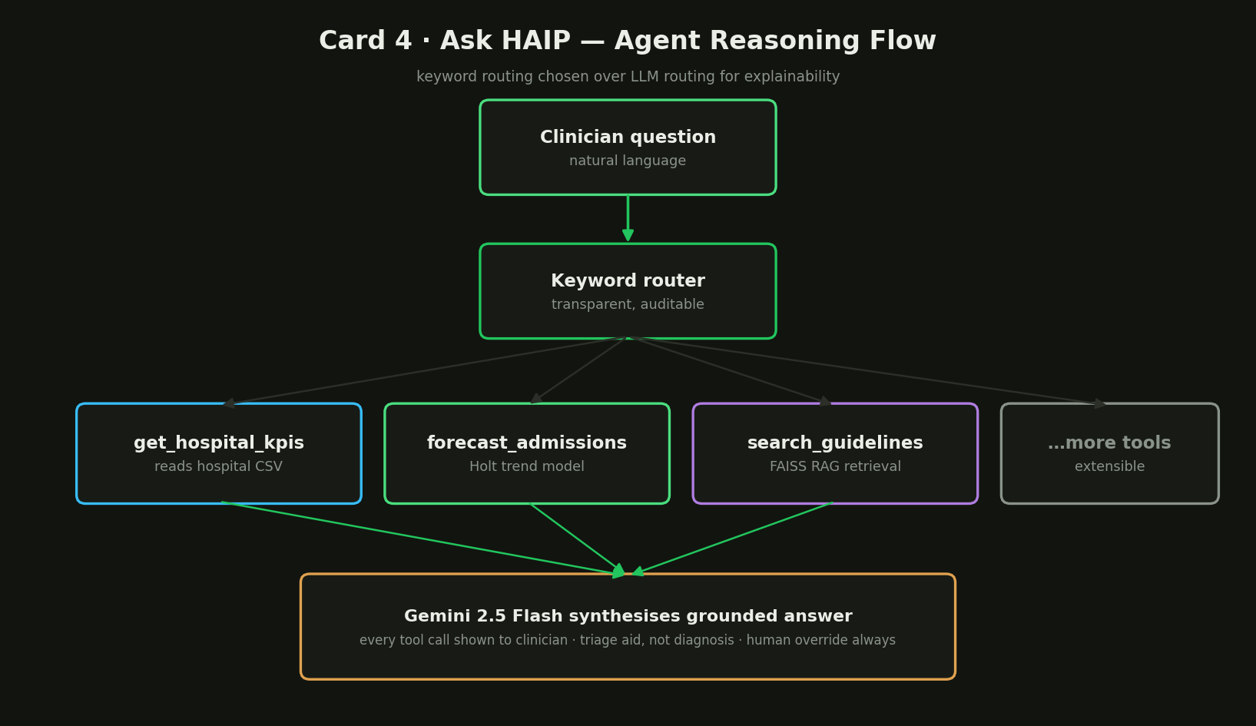
Figure 3 — Card 4 agent reasoning flow: keyword routing to real tools, synthesised by Gemini.

6. Tooling & Technology Choices (and the roads not taken)
Every technology in HAIP was chosen deliberately. This section explains what each tool does, why it was selected, and — importantly — why plausible alternatives were rejected. This is where the engineering judgement of the project lives.

6.1 Machine learning — XGBoost
XGBoost is a gradient-boosted decision-tree library. It was chosen for tabular clinical data because boosted trees consistently outperform deep networks on structured, medium-sized datasets, handle mixed feature types and missing values gracefully, and train quickly on a CPU-only machine. Why not deep learning? Neural networks need far more data than ~1,165 patients to beat trees on tabular problems, and they are harder to interpret — a poor fit for a clinical tool that must stay explainable.

6.2 Retrieval — FAISS + Sentence-Transformers
Embeddings use all-MiniLM-L6-v2 (Sentence-Transformers), a compact bi-encoder that produces good semantic vectors cheaply. Vectors are indexed in FAISS using an IndexFlatIP (exact inner-product search). Why exact search? With 6,832 chunks, an exact flat index is fast enough and returns perfect recall — no need for the accuracy trade-offs of approximate indexes at this scale.
Why not a cross-encoder re-ranker? A re-ranking stage was tested and removed. The bi-encoder retrieval was already saturating Hit@5, and the cross-encoder actually demoted a correct hit in testing. Keeping bi-encoder-only retrieval is the honest, better-performing choice — a good example of measuring rather than assuming.

6.3 The agent — LangGraph + Gemini + keyword routing
The agent is built on LangGraph (a ReAct-style agent framework) with Gemini 2.5 Flash as the grounded LLM. Routing to tools uses keyword routing rather than letting the LLM decide. Why keyword routing over LLM routing? Explainability. A keyword router is deterministic and auditable — a clinician (and an examiner) can see exactly why a tool fired. LLM routing is more flexible but opaque, which conflicts with the honest-engineering goal.
Why Gemini 2.5 Flash specifically? On the free tier it was the only reliably available grounded model: the 2.0 model had zero quota, and the lite variant was deprecated for new users. Flash offered the best capability-to-cost fit for a student project.

6.4 Interfaces — Dash, Streamlit, React
- Dash / Plotly (Cards 1 & 2) — best-in-class for interactive analytical dashboards with server-side callbacks.
- Streamlit (Card 3) — fastest path to a clean document-and-chat RAG interface.
- React / Vite (frontend) — a single, fast SPA shell that unifies the four cards behind one navigation and one visual theme.

6.5 Reporting & storage
- ReportLab — programmatic PDF generation for the hospital report.
- PyMuPDF — text extraction from uploaded hospital documents into the isolated RAG index.
- CSV + SQLite + FAISS — lightweight runtime storage chosen over a database cluster to stay within the machine's resource budget while remaining portable.

6.6 Forecasting — Holt exponential smoothing
Admission forecasting uses a Holt (trend-only) exponential-smoothing model. Why Holt over ARIMA or Prophet? The uploaded series are often short. Holt is stable on short series (≥ 4 months, no seasonal term), needs no heavy fitting, and degrades gracefully — a pragmatic fit for arbitrary user data, where a heavier model would overfit or fail.

7. Metrics & Evaluation
Because HAIP scores whatever dataset a user uploads, exact metric values are not fixed — they are recomputed on each dataset. What is fixed, and what matters, is the methodology: which metrics are used and why.

7.1 Why PR-AUC over ROC-AUC
Clinical risk targets are usually imbalanced — adverse events (mortality, readmission) are rare relative to normal outcomes. ROC-AUC can look flatteringly high on imbalanced data because it rewards correctly ranking the abundant negative class. PR-AUC (precision–recall AUC) focuses on performance on the rare positive class, which is exactly what a risk model must get right. Reporting PR-AUC is the honest choice for imbalanced clinical prediction, and HAIP uses it as the headline classification metric.

7.2 Retrieval metrics
The RAG component is evaluated with Hit@k — whether a correct guideline passage appears in the top-k retrieved chunks. As noted in §6.2, bi-encoder retrieval saturated Hit@5, which is why the cross-encoder re-ranker was dropped rather than kept for show.

7.3 How metrics stay honest
- Metrics are computed on the user's actual uploaded data, not cherry-picked.
- Limitations (synthetic training data, proof-of-concept status) are stated on-screen.
- Every automated decision allows human override — the system advises, it does not decide.

8. Unique Selling Point & Competitive Position
Commercial clinical-analytics tools tend to specialise: one product for BI dashboards, another for guideline lookup, another for risk scoring, and increasingly a separate LLM assistant. HAIP's differentiation is integration and honesty.

8.1 Where HAIP competes
Capability | Typical market | HAIP
Analytics dashboards | Standalone BI tool | Card 1 & 2, in-platform
Guideline lookup | Separate reference app | Card 3 RAG, cited
Risk prediction | Separate ML product | Card 1, on your data
Conversational agent | Bolt-on chatbot | Card 4, reasons across all cards

8.2 The USP in one line
HAIP is the only tool in this comparison where an agent can answer a single question using guidelines, live KPIs, and forecasts together — on the hospital's own data — while showing its work. Its second differentiator is disciplined honesty: bring-your-own-data, disclosed limitations, PR-AUC over ROC-AUC, and human-in-the-loop by default.

9. Testing & Quality
Quality was an explicit examiner requirement. HAIP has an automated pytest suite (16 tests passing) covering the analytics KPI computations and the agent's tools (the KPI reader and the forecast tool), plus a manual browser walkthrough checklist covering all four cards end-to-end. Tests were written to reflect the real, current architecture — CSV-backed tools rather than the retired database paths — so they exercise what the system actually does.

10. How It All Works Together
A representative end-to-end session shows the pieces connecting:
- The user signs in (FastAPI auth) and lands on the four-card selector in the React UI.
- They open Card 1, upload their hospital CSV, and the system validates and maps columns.
- EDA charts render; XGBoost scores risk; the Holt model forecasts admissions; a PDF report is exported.
- In Card 3 they ask a clinical question and get a cited answer drawn from WHO/CDC/NICE guidance.
- In Card 4 they ask a combined question — "what are our current KPIs and what does guidance say about sepsis screening?" — and the agent calls the KPI tool and the guideline tool, then Gemini synthesises a grounded answer with the tool trail shown.
The result is the connected, end-to-end workflow the project set out to build: backend, frontend, analytics, and reporting joined into one experience.

11. Conclusion
HAIP demonstrates that a single student, on a single machine, can build a genuinely integrated clinical-support platform: four connected capabilities, a working agent on top, real reports and forecasts, and a test suite — all delivered with honest engineering rather than inflated claims. It solves the fragmentation problem by unifying analytics, guidelines, prediction, and a reasoning agent behind one interface that runs on the hospital's own data.
Its most important quality is not any single model score but its discipline: measured decisions (dropping the re-ranker), honest metrics (PR-AUC), disclosed limitations (synthetic data, proof-of-concept), and human-in-the-loop by default. That is the right foundation for anything intended to support clinical work.

12. Future Implementations
HAIP is a proof-of-concept with a clear path to a more production-ready system. Planned and possible next steps, roughly in priority order:

Near-term
- Google OAuth — replace basic auth with proper single-sign-on.
- Airflow orchestration — schedule the upload → predict → report pipeline as a managed workflow.
- Bake dependencies into images — make the RAG service's Python dependencies permanent so the container is fully reproducible from a clean build.

Infrastructure & scale
- Persistent vector store — pre-build the FAISS index (and optional re-rank model) into the image to remove cold-start downloads.
- Storage relocation — move the Docker data root to a larger dedicated volume to remove the disk-space constraint.
- Shared base image — collapse duplicate layers across the Python services to cut image bloat.

Product & clinical
- Real-data pilot — with appropriate governance, validate models on de-identified real data.
- Model monitoring — track prediction drift and recalibrate as data changes.
- Expanded agent tools — the keyword-routed tool set is extensible; more clinical tools can be added without changing the architecture.
HAIP · proof-of-concept on synthetic data · a triage aid, not a diagnostic decision

